**Assignment 2**

**Question 1**

**What is the value of clothes[0] and why?**

**const clothes = ['jacket', 't-shirt'];**

**clothes.length = 0;**

**console.log(clothes[0]);**

**Ans.**

**Code:**

<!DOCTYPE HTML>

<html>

<head>

<title>Array</title>

</head>

<body>

<script type="text/javascript">

const clothes = ['jacket', 't-shirt'];

clothes.length = 0;

console.log(clothes[0]);

</script>

</body>

</html>

**Output:**

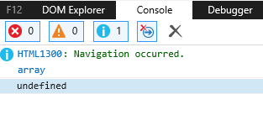

**Explanation:**

When JavaScript executes clothes.length=0, all the items of the array clothes are deleted.

Closthes[0] is undefined , because clothes array was emptied.

**Question 2**

**Write a JavaScript program to find the sum of all elements of a given array?**

**Ans.**

**Code:**

<!DOCTYPE HTML>

<html>

<head>

<title>Sum</title>

</head>

<body>

<script type="text/javascript">

var array=[2,4,1,5,7],

s=0,

i;

for(i=0;i<array.length;i++)

{

s+=array[i];

}

console.log("Sum of all element : "+s);

</script>

</body>

</html>

**Output:**

